**I. Definition**

### Project Overview

In a world where advertising is becoming increasingly competitive, it is becoming also more and more important to target your audience accurately in order to ensure your business can continue to thrive.

With the recent advancements in computing, machine learning algorithms are now largely available in a number of frameworks that makes it easy for everybody to train and use. Leveraging this new technology to target your customers accurately is nowadays paramount.

Starbucks is a coffee company that was founded in 1971 in Seattle and despite his strong presence is the market, the recent pandemic hit the sector quite strongly.

Starbucks reported his first quarterly loss in 7 years (source: <https://www.ft.com/content/4c876c5a-a03a-3f57-8a04-c364b12ad4b7>) and many bars and restaurants had to close down as their profitability was strongly undermined by the social distancing guidelines put in place by world governments.

### Problem Statement

Starbucks wants to improve the way it proposes deals and offers through the app to its customers.

The aim of this project is to leverage machine learning algorithms to increase revenue by targeting the right audience and drawing them to the stores.

The goal of this project is to analyse historical data to draw insights and create a model to better target customers.

### Metrics

For the issue at hand we are going to use accuracy as metric to evaluate the machine learning algorithm.

The problem at hand is a binary classification problem, and the dataset at hand is balanced.

Furthermore, the business does not incur any severe consequence in case of a false positive or a false negative.

## II. Analysis

### Data Exploration

In this first section we are going to explore the 3 datasets at hand.

We will also use plots to get a sense of what data is avaiable and how we might want to use it.

The goal of this phase is to get an insight on the datasets at hands and identify potential issues to tackle.

*Portfolio Dataset*

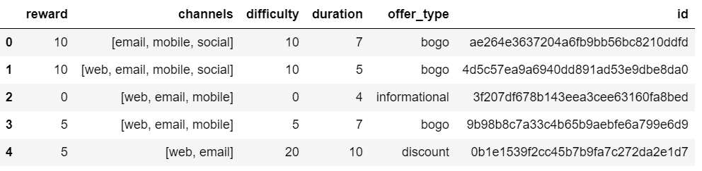

The portfolio has information about the offers Starbucks put forward. We see that 2 columns need to be one-hot encoded: Channels and offer_type.

The following are the offer types: email, mobile, social, web.

Some of the features inside the Portfolio dataset are highly informative for the problem we are trying to tackle, for instance the higher the duration, the more likely the offer is completed.

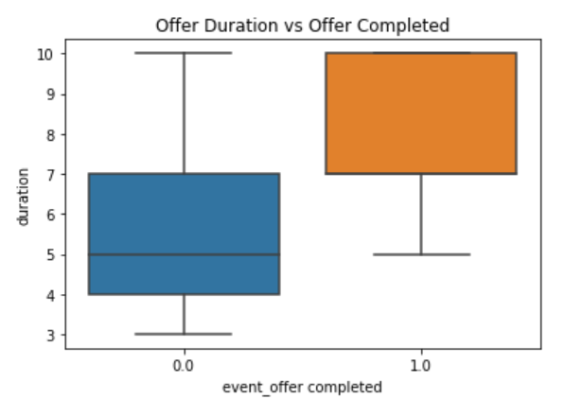

*Profile Dataset*

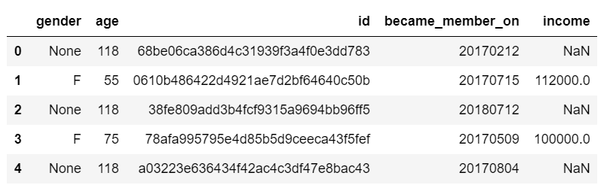

We have a number of missing values and all of them coincide with age 118. We have removed those.

We will need to one hot encode gender andtransform the variable "became_member_on" to something that tells us the customer tenure, such as number of days since customer joined.

The following are the distributions of age and income with median values 55 and 64k respectively:

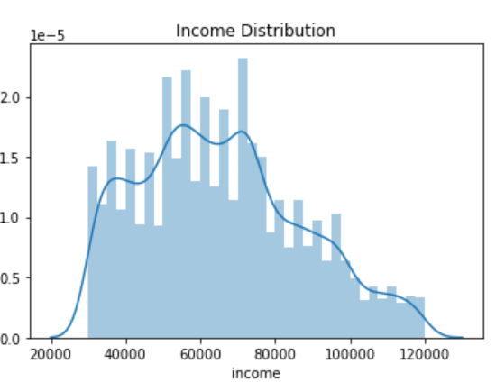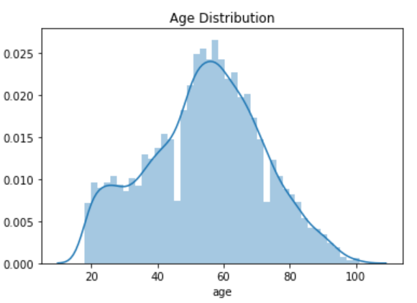

Income appears to be more influential than age in separating whether `an offer is completed.

Higher Income increases the chances of completing the order.

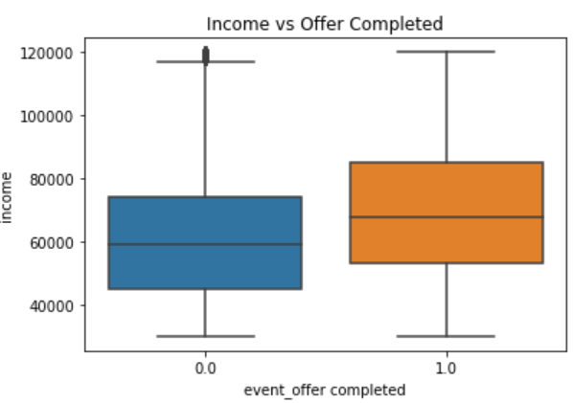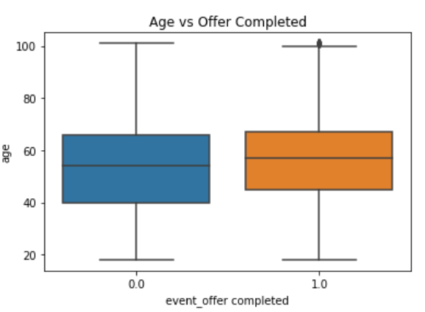

*Transcript Dataset*

The transcript dataset is essentially a mapping between the event and the offer

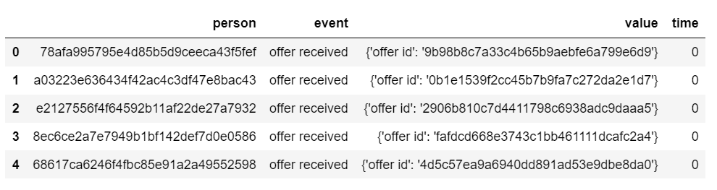

*Combined dataset*

This is what the dataset looks like once we have preprocessed them and combined them:

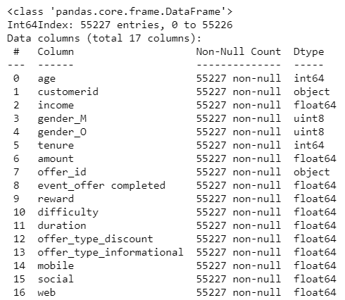

The dataset has now many dimensions and to further explore the separation between orders completed or not across all dimensions we are going to leverage a dimension reduction technique, Principal Component Analysis.

Using this technique, we can reduce the dimensionality of the data to 3 for the purpose of the visualization, retaining most of the variability in the original dataset.

Due to the high presence of categorical features, the points are sort of clustered towards the central axis.

But we do see a clear separation between the green and the red points, but also an area where they strongly overlap. We will need a strong classifier in a hyperdimensional space to achieve high accuracy.

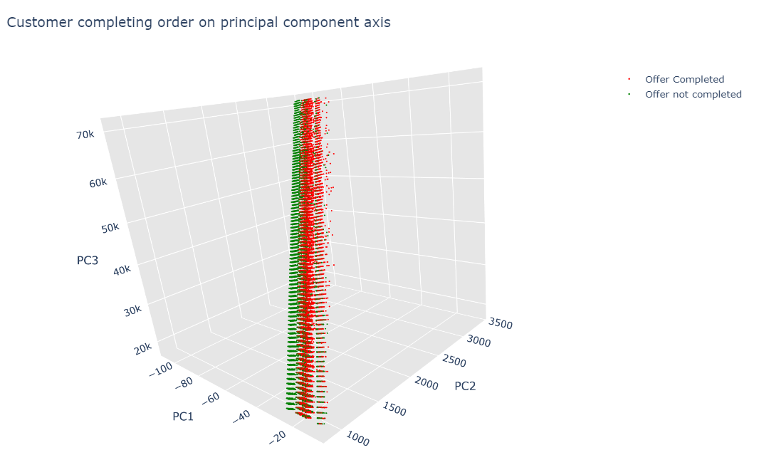

## III. Methodology

### Data Preprocessing

The following pre-processing steps have been carried out:

1. One Hot encode the offer_type column from the portfolio dataset
2. One Hot encode the channels column from the portfolio dataset
3. One Hot encode the gender column from the profile dataset
4. Transform the became_member_on column into tenure days
5. Remove missing values from profile dataset
6. Remove events not offer related from transactions dataset
7. Extract offer ID from value column in transactions dataset
8. Reshape the transaction dataset to have the event type as one hot encoded column
9. Extract total amount spent from transactions for each customer
10. Create a column to mark whether an offer was successful or not
11. Join the 3 datasets and create a unique dataframe

The one hot encoding was necessary as algorithms only read numerical data. No data scaling was performed at this stage as the 2 algorithms that we have selected are tree based, random forest and XGBoost. They are not distance based algorithm such as SVM or KNN, or neural networks, so scaling is not necessarily required.

We have then split the dataset into training and test set using a 85:15 split.

### Implementation

For the implementation we have leveraged the scikit learn library. It provides ready to use implementation of the algorithms we have chosen.

In order to evaluate them, we chose to use cross validation techniques.

Fitting the algorithms on the training set alone can lead to overfitting and it’s important to see how these algorithm generalize.

We have therefore leveraged stratified cross validation and obtained the mean accuracy achieved on the out of sample prediction.

### Refinement

We then proceeded to fine tune the hyperparameters of XGBoost and Random Forest to improve the generalization on the test set.

Hyperparameter tuning has been implemented using Randomized search over a set of combination of parameters. 50 combinations have been searched and the best has been fitted.

We have then fitted the tuned models and evaluate their performance on the test set.

## IV. Results

We have evaluated the accuracy of our models using a test set, data that the model has not trained on and that represents the performance on out of sample data.

The following are the accuracies achieved by the models we have trained:

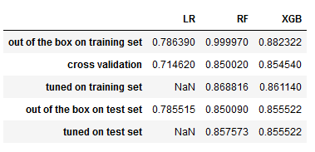

The best performing model is RandomForest classifier, with the tuned hyperparameters. We reached this conclusion after looking at the accuracy it achieved on the test set, which is 85.7%.

The performance of this new classifier far outperforms that of our benchmark, logistic regression which achieved 78.5% accuracy on the test set and it is also higher than the current performance of the starbucks model, where only 59% of the offers gets completed.

Furthermore, our recommendation is to focus on the amount,reward and duration of the offer as they the most influential features in determining whether an offer gets completed or not. See Feature importance extract of the tuned classifier below:

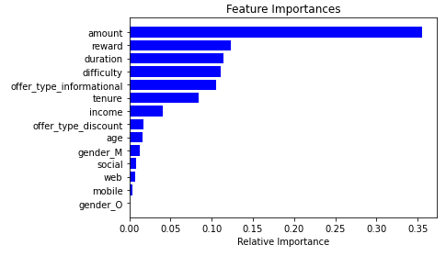

## V. Conclusion

In this project I have imported,cleaned and analysed a dataset provided by Starbucks.

We have engineered the data to extract features for the algorithms, and I was able to create a Supervised Learning model with an accuracy of 85.7% with a big improvement over the current 59% success rate of the model employed by Starbucks.

This is a considerable achievement as this model could boost revenue if used correctly to attract customers.

**Further Steps:**

It is important to note that the possibility with a dataset are endless and there are many more things that we could have tried to do. I hereby list a few:

1) check other classification algorithms

2) fine tune the models again by searching for longer to find better hyper parameters

3) perform further feature engineering to create more features that might help the algorithm increase accuracy

4) perform error analysis by looking at false positives or false negatives to understand why they were wrongly classified

5) try more complex models such as neural networks